Evaluation Only. Created with Aspose.Words. Copyright 2003-2014 Aspose Pty Ltd.

Evaluation Only. Created with Aspose.Words. Copyright 2003-2014 Aspose Pty Ltd.
Electronic.Statement@sc.com
From: Electronic.Statement@sc.com
Sent: 3 Nov 2014 07:48:03 +0500
To: saqib.razzaq@gmail.com
Subject: Your e-Statement SAQIB RAZZAQ(Aspose.Email Evaluation)
Attachments: 8EF4DB293C9EB59BF3021AC6BAA4D9904249CDAEE74065E3.pdf

This is an evaluation copy of Aspose.Email for .NET.

View EULA Online


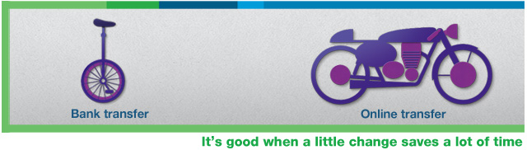
Dear Customer,
Attached please find your e-Statement.
Offers
Standard Chartered's 'Good Life' program lets you enjoy your preferred lifestyle with amazing discounts in
Pakistan and UAE.

For a complete list of discounts in UAE, please visit sc.com/ae/privileges.
For more details on discounts and privileges, please visit sc.com/pk/thegoodlife
Apply Online
- Ready Cash

- Personal Loan

- Credit Card
For details visit us at sc.com/pk
Contact us on: Ask.Us@sc.com
Standard Chartered Bank (Pakistan) Limited
This email and any attachments are confidential and may also be privileged. If you are not the intended recipient, please delete all copies and notify the sender immediately. You may wish to refer to the incorporation details of Standard Chartered PLC, Standard Chartered Bank and their subsidiaries at https://www.sc.com/en/incorporation-details.html.

